P.E. May 4rd.-8th.
Monday  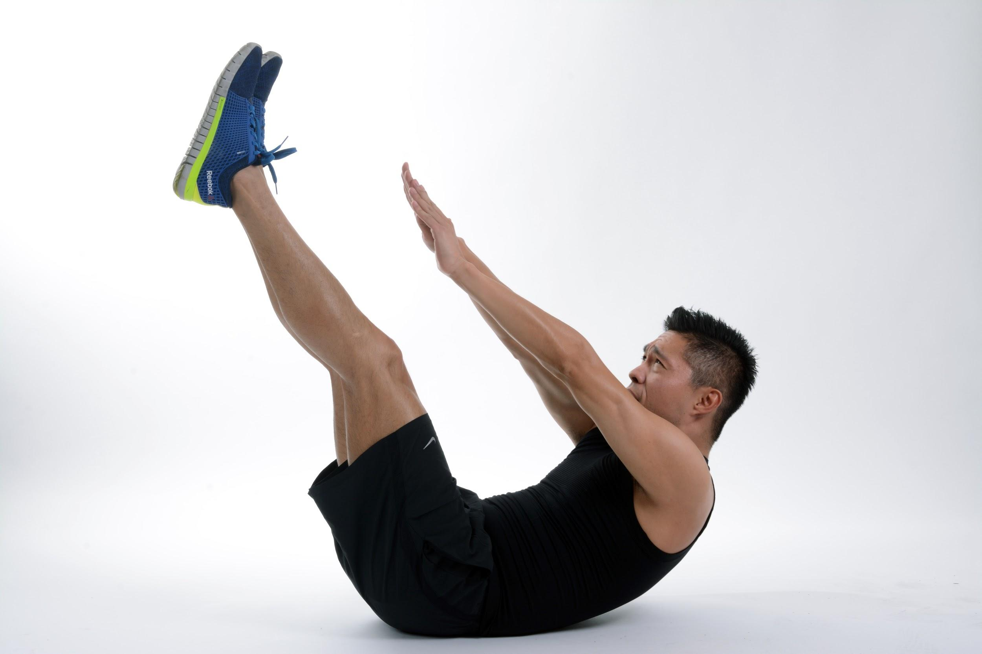  PE at Home: Fan Favorite From OPEN physed | Tuesday  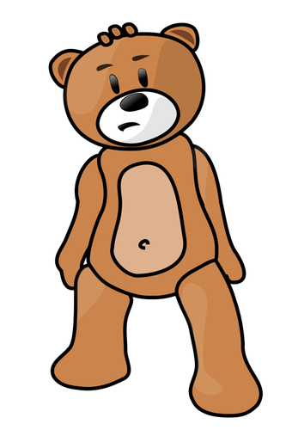  PE at Home: Teddy Bear Transport from Justin Cahill @JustybubPE
Wednesday  PE at Home: Foot Trap Soccer | Thursday  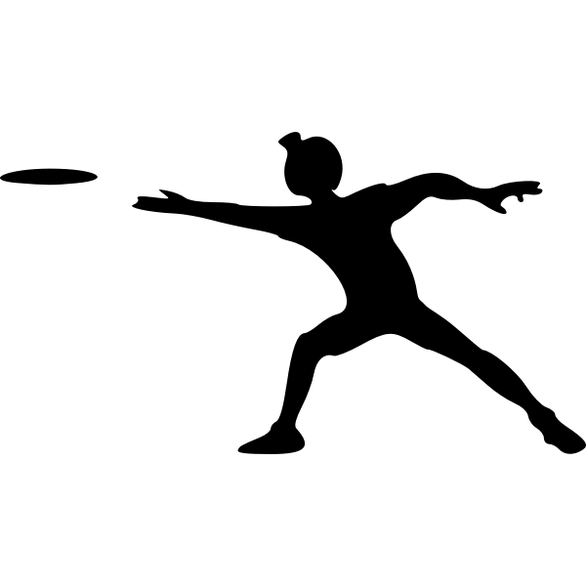  PE at Home: Homemade Frisbee Fling
Friday  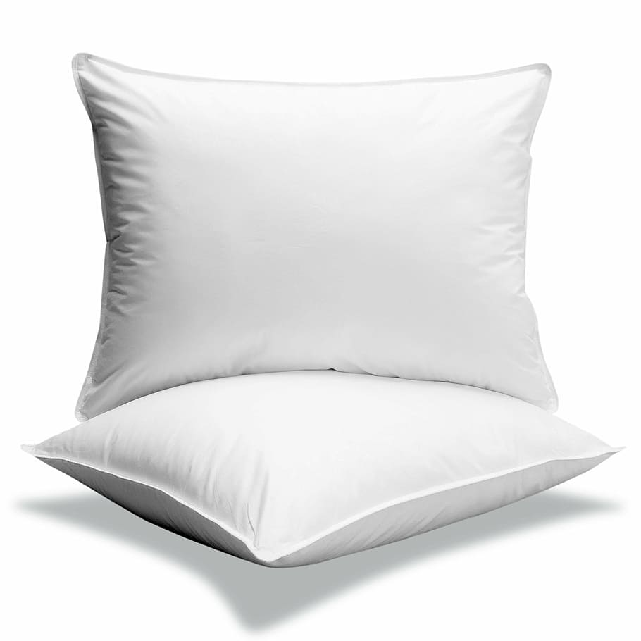  PE at Home: The Scooter Pillow Race | Good Luck and have fun!!!

