BLT Senior Elementary School
Grade 2 French Immersion School Supplies List 2025-2026

Hello everyone! This year, we will be using the Classroom Community Supply System. This means that most items will be collected, stored, and shared among the class. Sharing supplies helps to promote a sense of classroom community and shared responsibility.
Please DO NOT label anything except indoor shoes and headphones 🙂
We are looking forward to seeing everyone in September!
✔ | Qty | Item
 | 2 | Hilroy Exercise Book Plain (Blue) | 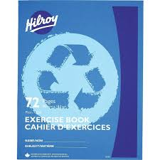
 | 5 | Duo-Tangs*  (1 Yellow, 1 Blue, 1 Red, 1 Purple, 1 Orange)  *colours help your child with organization | 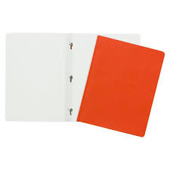
 | 1 | Duotang with Pocket Folder  (Green) | 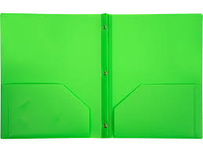
 | 1 | Pocket Folder | 
 | 2 | Package of 20 Led Pencils (Pre-sharpened) | 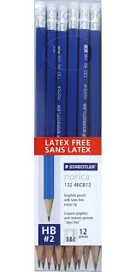
 | 2 | White Erasers | 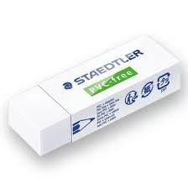
 | 2 | Package of 4 Dry Erase Markers | 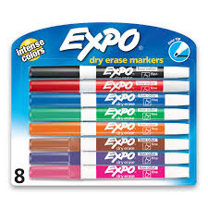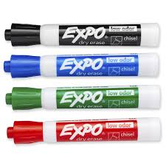
 | 2 | Black Medium Point Sharpie Markers | 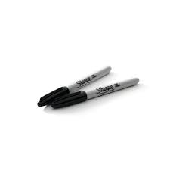
 | 1 | Pair of Blunt Tip Scissors | 
 | 4 | Packages of 24 Wax Crayons | 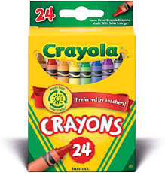
 | 1 | Package of 10 Washable Coloured Markers | 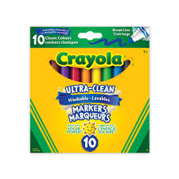
 | 3 | Large Glue Sticks (Preferably Elmer’s) | 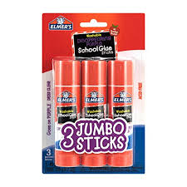
 | 1 | Small Pencil Case | 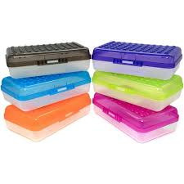
 | 1 | Pair of Indoor Sneakers (Labeled)
 | 1 | Headphones (Labeled)
 | Optional | Box of Kleenex  Baby Wipes  Large Ziploc Bags

