Please DO NOT label anything except scissors, indoor shoes and headphones.
Feel free to reuse any supplies that are in good condition from years past. 🙂

✔ | Quantity | Item
 | 2 | - Hilroy Exercise Book ½ Plain and ½ Interlined; 1 green and 1 yellow  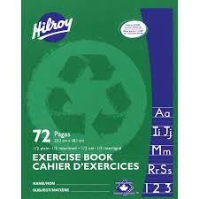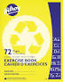
 | 5 | - Paper Duo-Tangs (1 Red, 1 Blue, 1 Green, 1 Black, 1 Yellow )  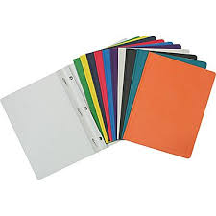
 | 2 | - Twin Plastic Pocket Folder (2 clear)  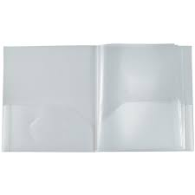
 | 1 | - Hilroy 32 page lined exercise book
 | 2 | - Packages of 36 HB Pencils (Sharpened)
 | 1 | - Personal Pencil Sharpener (with container to collect shavings)  (labeled)
 | 1 | - Tool kit
 | 4 | - White Erasers
 | 14 | - Black Dry Erase Markers
 | 2 | - Packages of 24 Wax Crayons
 | 2 | - Package of 10 Washable Coloured Markers
 | 3 | - Large Glue Sticks
 | 1 | - Scissors (labeled)
 | 1 | - Pair of Indoor Sneakers (Labeled)
 | 1 | - Headband style/LabeledHeadphones (No bluetooth or Wireless)

